Problem 3:

Given, P(s) = $\frac{K}{Ts^{α}+1}$; C(s) = $K_{p}(1+\frac{K_{i}}{s^{β}})$;

where K=1, T=0.4, α=0.5, β=1.216, $K_{i}$ =194.4, $K_{p}$ =0.1817

C(s) = $K_{p}(1+\frac{K_{i}}{s^{β}})$ = $K_{p}$ ($\frac{s^{β}+Ki}{s^{β}}$) = $K_{p}$ ($s^{β}+Ki$) ($\frac{1}{s^{β}}$);

L(s) = P(S)C(s)

= ( $\frac{K}{Ts^{α}+1})$ $(K_{p}$) ($s^{β}+K_{i}$) ($\frac{1}{s^{β}}$)

= ($K_{p}$)($\frac{K}{Ts^{α}+1}$) ( $s^{β}+K_{i})$ ($\frac{1}{s^{β}}$)

Putting the given values

L(s) = (0.187) ($\frac{1}{0.4s^{0.5}+1}$) $(s^{1.216}+194.4)$ ($\frac{1}{s^{1.216}}$)

Now separating all the basic terms from L(s) = ($K_{p}$) ($\frac{K}{Ts^{α}+1}$) ( $s^{β}+K_{i})$ ($\frac{1}{s^{β}}$), the asymptotic calculation of $K_{p},$ $\frac{K}{Ts^{α}+1}$, ( $s^{β}+K_{i}) and$ $\frac{1}{s^{β}}$ is shown below

1. For , |T(jω)| = 20log ($K_{p}$)

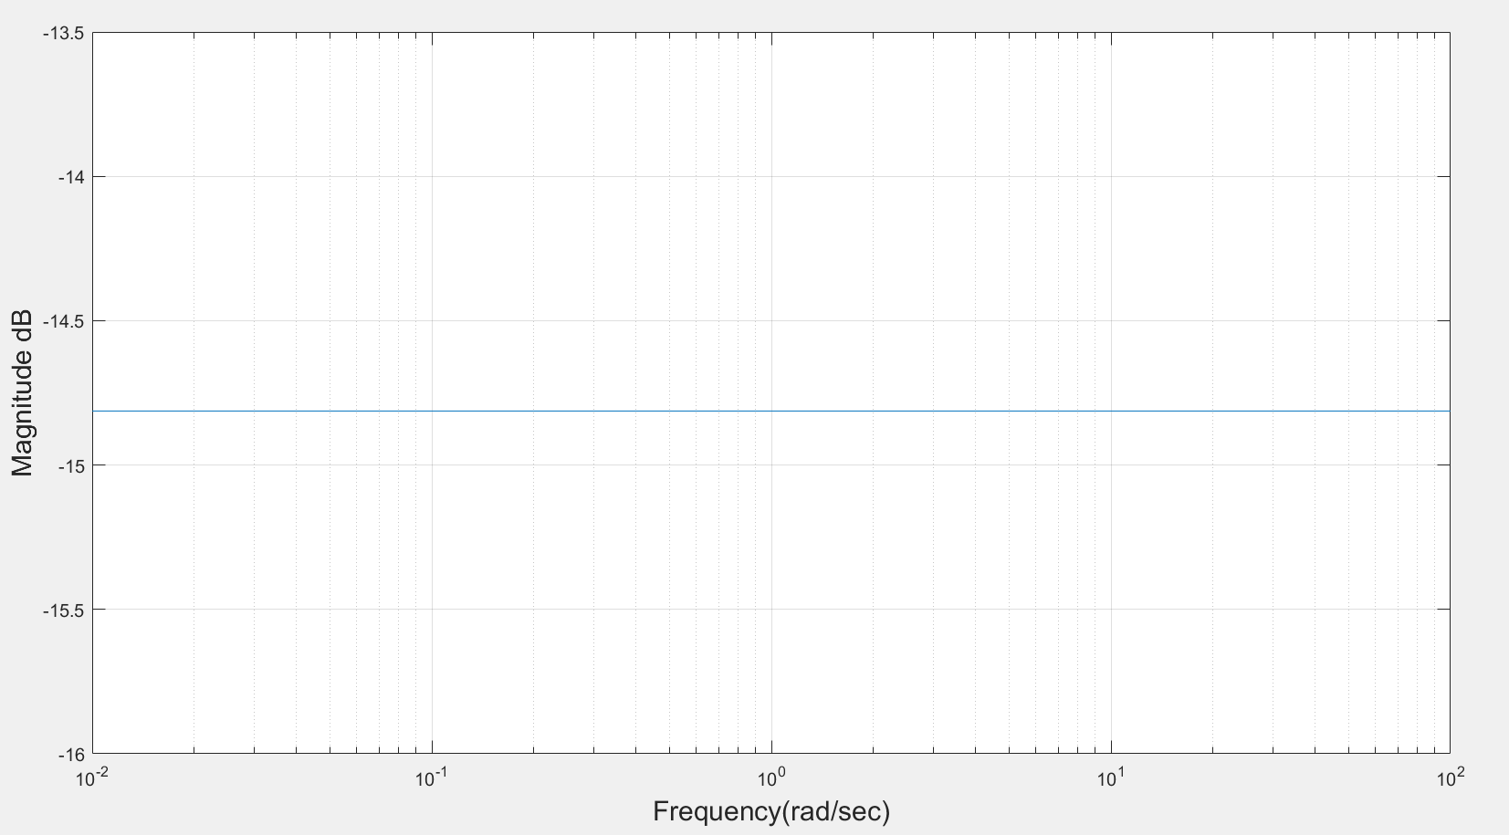

Figure 1: Asymptotic magnitude bode plot for constant gain, $K_{p}$

1. For, ($s^{β}+K_{i})$

Fractional zero transfer function is given by T(s)= $s^{β}+K_{i}$…... (1)

Put s = jω, in equation (1) results into T(jω) = $({jω)}^{β}+K_{i}$…… (2)

Magnitude in dB is given by |T(jω) | dB = 20log ( $\sqrt{{K_{i}}^{2}+ω^{2β}+2{K_{i}ω}^{β}\cos{\frac{πβ}{2}}}$)

**Calculation procedure**

$({jω)}^{β}$

= $({0+1j)}^{β}$ = ${\text{(cos}\frac{π}{2}+j\text{sin }\frac{π}{2}\text{)} }^{β}ω^{β}$

Applying De Moivre’s theorem in above equation we get

= $\text{(cos}\frac{βπ}{2}+j\text{sin }\frac{βπ}{2}\text{)}ω^{β}$…… (3)

Put equation (3) in (2) we get

T(jω) = $\text{(cos}\frac{βπ}{2}+j\text{sin }\frac{βπ}{2}\text{)}ω^{β}$ + $K_{i}$

= $\text{(}ω^{β}\text{.cos}\frac{βπ}{2}+K_{i})$ + $jω^{β}\text{sin }\frac{βπ}{2}$

Magnitude, |T(jω) | =

=

Now, Magnitude in dB, |T(jω) | dB = 20log ${\text{(}ω^{2β}\text{+ }{K_{i}}^{2}\text{+ }2ω^{β}K_{i}\text{cos}\frac{βπ}{2}\text{)}}^{\frac{1}{2}}$

In the sum ${(ω}^{2β}\text{+ }{K_{i}}^{2}\text{+ }2ω^{β}.K_{i}\text{cos}\frac{βπ}{2}$), ${K_{i}}^{2}$ dominates at lower frequencies whereas $ω^{2β}$ dominates at higher frequencies.

For approximation we consider ${K_{i}}^{2}$ = $ω^{2β}|_{ω=ω_{cr}}$.We obtain corner frequency, $ω_{cr}$ = ${|K_{i}|}^{\frac{1}{β}}$

Now, following approximation of magnitude is obtained:

1. For ω ≤ , |T(jω) | dB = 20log ${({K_{i}}^{2})}^{\frac{1}{2}}$ = 20log||
2. For ω >, |T(jω) | dB = 20log ${(ω^{2β})}^{\frac{1}{2}}$ = 20βlog ω

**Procedure**

* Compute the corner frequency $ω_{cr}$ = ${|K_{i}|}^{\frac{1}{β}}$ and locate the point at magnitude 20log||.
* Draw a slope 0 dB/decade for ω ≤ $ω_{cr}$ and a line with slope 20β dB/decade for ω> $ω_{cr}.$

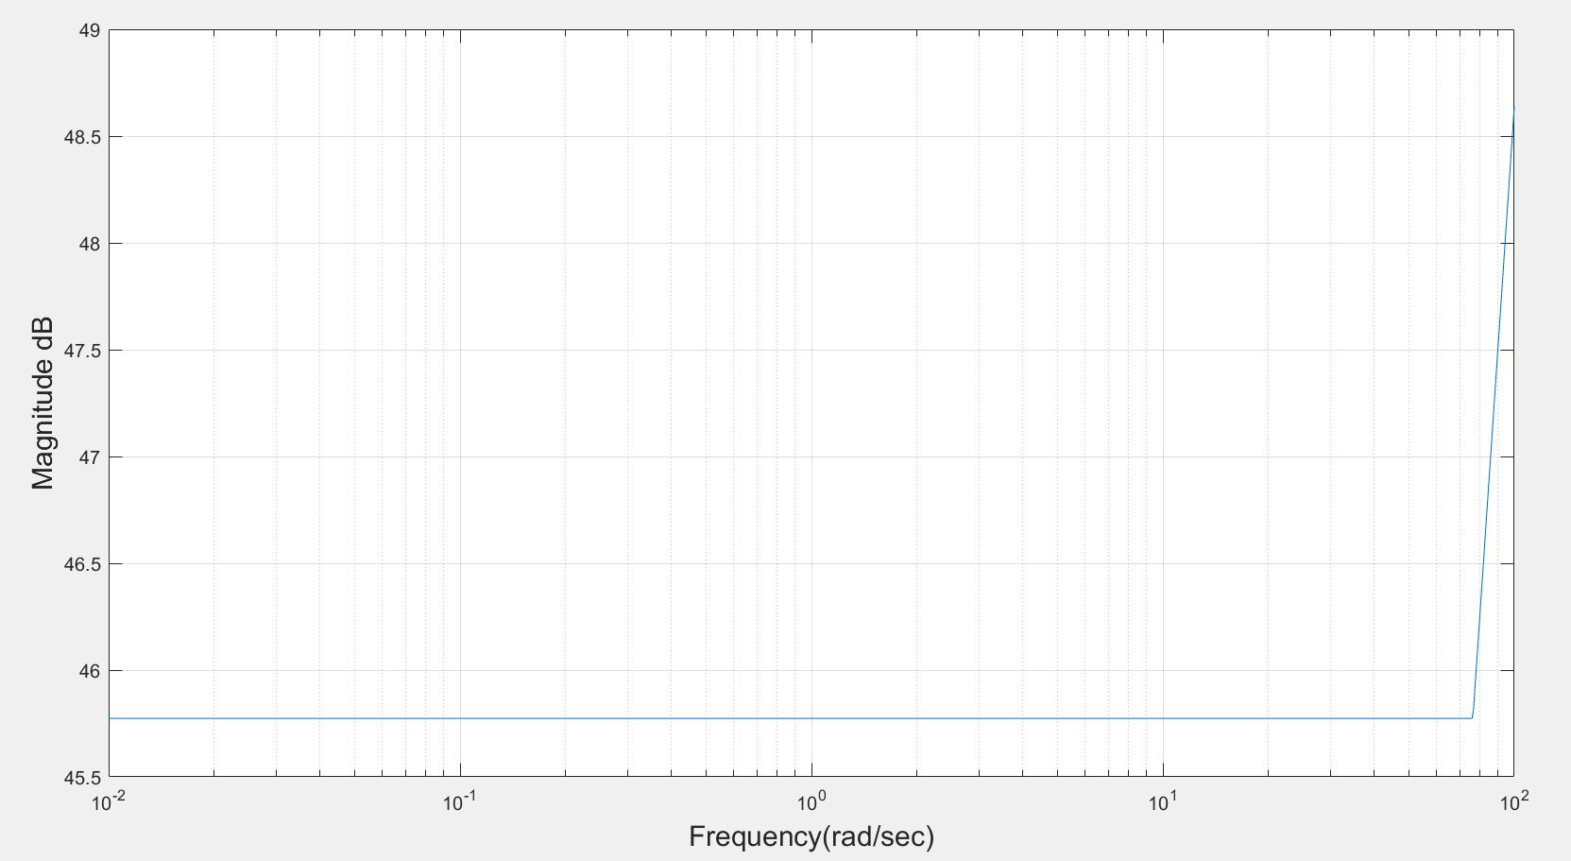

Figure 2: Asymptotic magnitude bode plot for ($s^{β}+K_{i})$

1. For, $\frac{1}{s^{β}}$

Fractional zero transfer function is given by T(s) = $\frac{1}{s^{β}}…$…… (1)

Put s = jω, in equation (1) results into T(jω) = $\frac{1}{{jω}^{β}}$……. (2)

Magnitude in dB is given by |T(jω)| dB= -20βlogω

**Calculation procedure**

$({jω)}^{β}$ = $({0+1j)}^{β}$ = ${\text{(cos}\frac{π}{2}+j\text{sin }\frac{π}{2}\text{)} }^{β}ω^{β}$

Applying De Moivre’s theorem in above equation we get

= $\text{(cos}\frac{βπ}{2}+j\text{sin }\frac{βπ}{2}\text{)}$. $ω^{β}$…… (3)

Put equation (3) in (2) we get

T(jω) = $\frac{1}{ω^{β}.cos\frac{βπ}{2} + jω^{β}sin \frac{βπ}{2}}$

Magnitude, |T(jω) | = =

Magnitude in dB is given by |T(jω) | dB= -20βlogω.

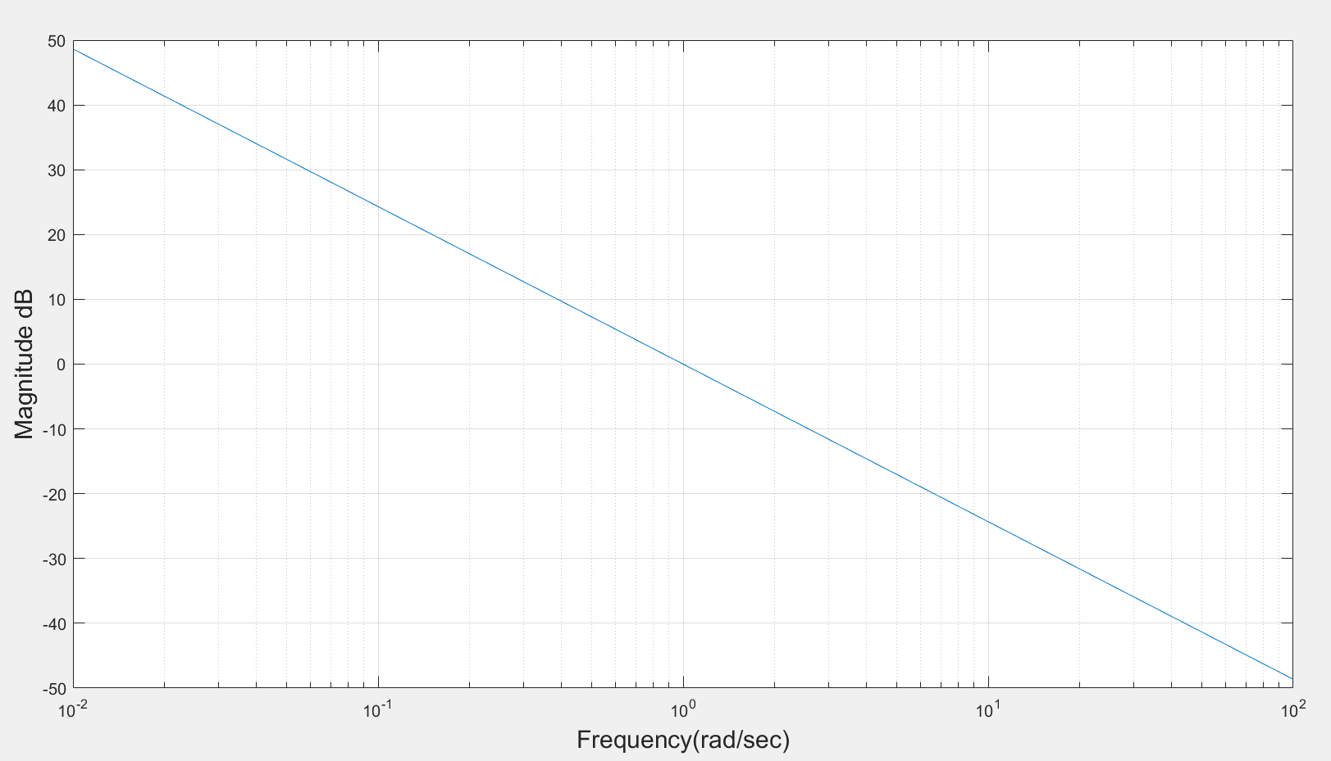

Figure 3: Asymptotic magnitude bode plot for $\frac{1}{s^{β}}$

1. For $\frac{K}{Ts^{α}+1}$, putting K=1 and T = 0.4

T(s) = $\frac{1}{0.4s^{α}+1}$ now put s=jw

T(jw) = $\frac{1}{0.4{(jw)}^{α}+1}$--------(a)

Now,

$({jω)}^{α}$ = $({0+1j)}^{α}$ = ${\text{(cos}\frac{π}{2}+j\text{sin }\frac{π}{2}\text{)} }^{α}ω^{α}$

Applying De Moivre’s theorem in above equation we get

= $\text{(cos}\frac{απ}{2}+j\text{sin }\frac{απ}{2}\text{)}$. $ω^{α}$…… (b)

Putting (b) in (a)

T(jω) = $\frac{1}{\{0.4(cos\frac{απ}{2}+jsin \frac{απ}{2}) ω^{α}\}+1}$ = $\frac{1}{\left(0.4ω^{α}cos\frac{απ}{2}+1\right)+ j0.4ω^{α}sin \frac{απ}{2}}$

Magnitude, |T(jω) | =

=

=

Now, Magnitude in dB, |T(jω) | dB = -20log ${\text{(}{0.16ω}^{2α}\text{+ }1^{2}\text{+ }0.8ω^{α}\text{cos}\frac{απ}{2}\text{)}}^{\frac{1}{2}}$

In the sum ${0.16ω}^{2α}\text{+ }1^{2}\text{+ }0.8ω^{α}\text{cos}\frac{απ}{2}$, $1^{2}$ dominates at lower frequencies whereas $0.16ω^{2β}$ dominates at higher frequencies.

For approximation we consider $1^{2}$ = $0.16ω^{2α}|_{ω=ω_{cr}}$.We obtain corner frequency, $ω_{cr}$ = ${|\frac{1}{0.4}|}^{\frac{1}{α}}$.

Now, following approximation of magnitude is obtained:

1. For ω ≤ , |T(jω) | dB = -20log ${(1^{2})}^{\frac{1}{2}}$ = -20log|1|.
2. For ω >, |T(jω) | dB = -20log ${(0.16.ω^{2α})}^{\frac{1}{2}}$ = -20αlog (0.4.ω)

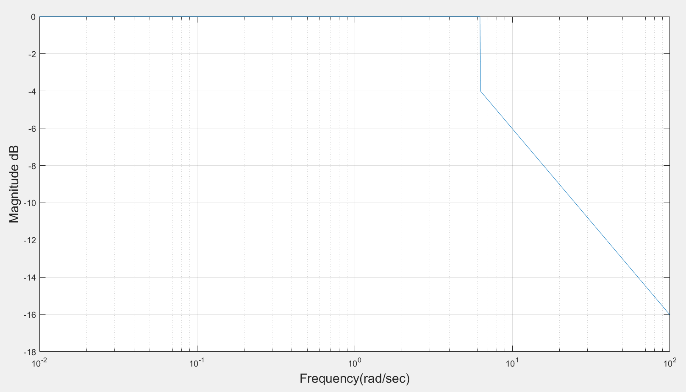

Figure 4: Asymptotic magnitude bode plot for $\frac{K}{Ts^{α}+1}$

1. L(s) is composed of basic terms, by adding the asymptotic plot of ( $\frac{K}{Ts^{α}+1}),$ $(K_{p}$), ($\frac{1}{s^{β}}$) and ($s^{β}+K_{i}$) one can find asymptotic plot for L(s)

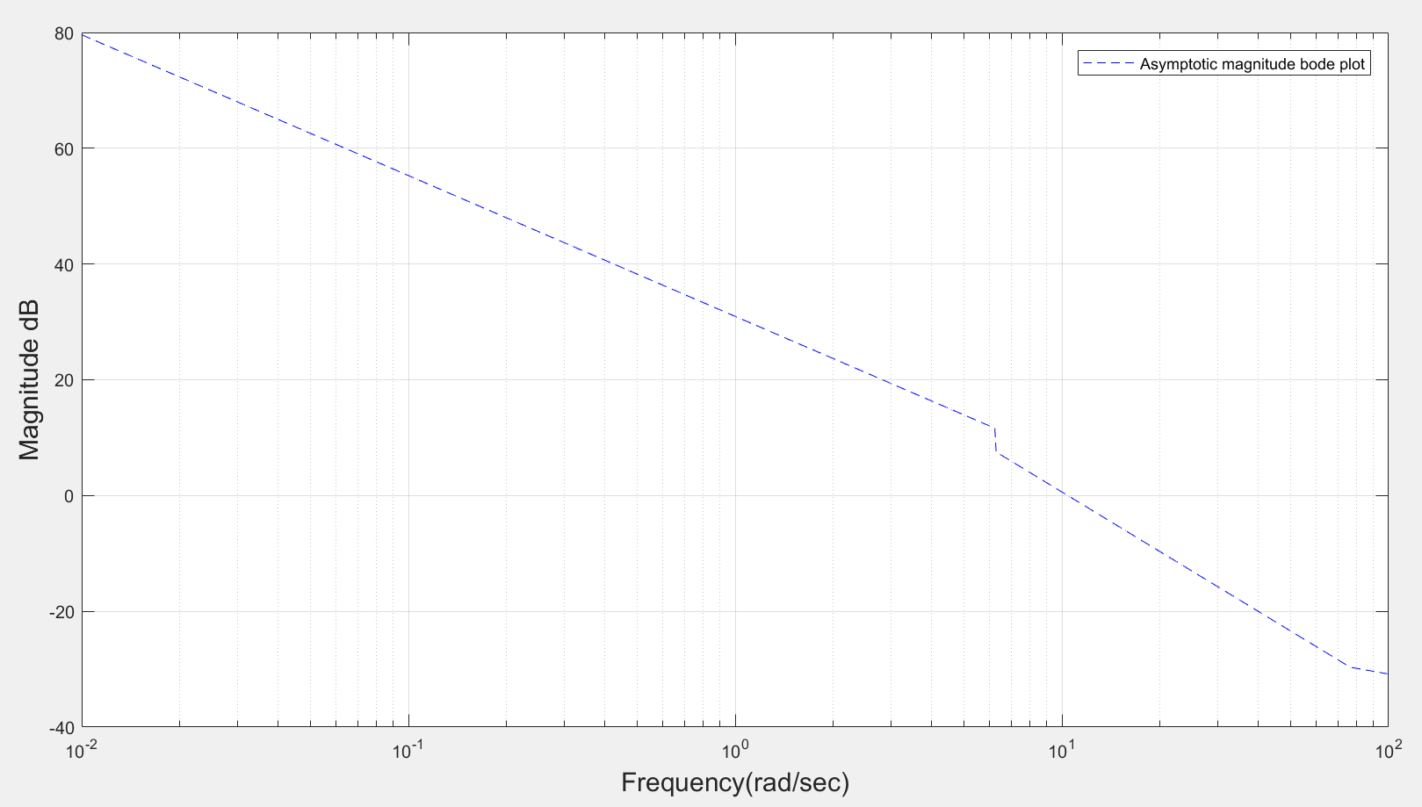

Figure 5: Asymptotic magnitude bode plot for L(s)

1. For exact magnitude bode plot of L(s)

L(s) = P(S)C(s)

= $\frac{K}{Ts^{α}+1}$ $K_{p}$ ($s^{β}+K_{i}$) ($\frac{1}{s^{β}}$)

= ($K_{p}$)($\frac{K}{Ts^{α}+1}$) ( $s^{β}+K_{i})$ ($\frac{1}{s^{β}}$)

Now,

Magnitude, |L(jω)| = 20log ${\{(K_{p})( \frac{K}{T{jω}^{α}+1}) ({jω}^{β}+K_{i}) (\frac{1}{{jω}^{β}})\}}^{\frac{1}{2}}$

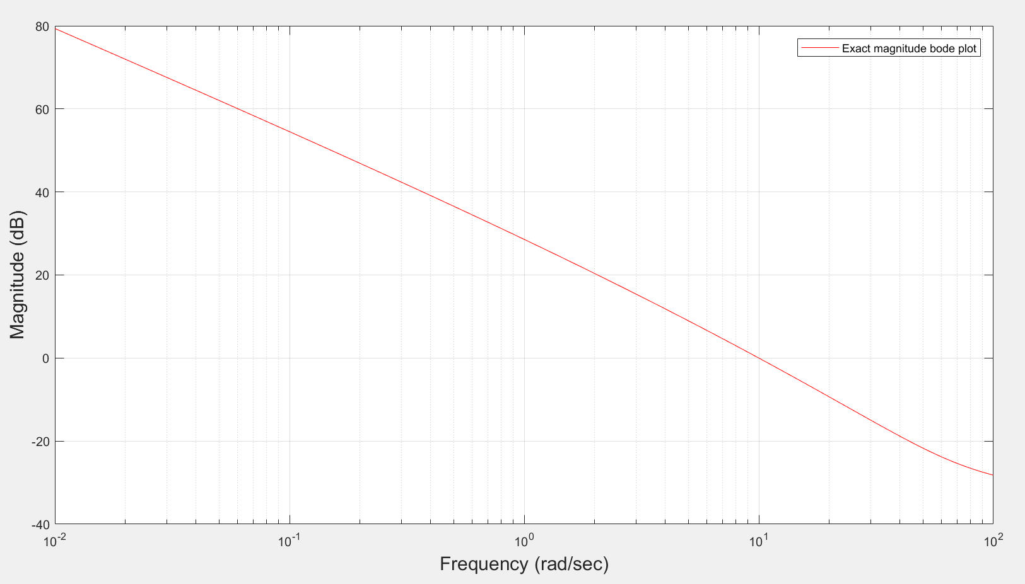

Fig 6: Exact magnitude bode plot for L(s)

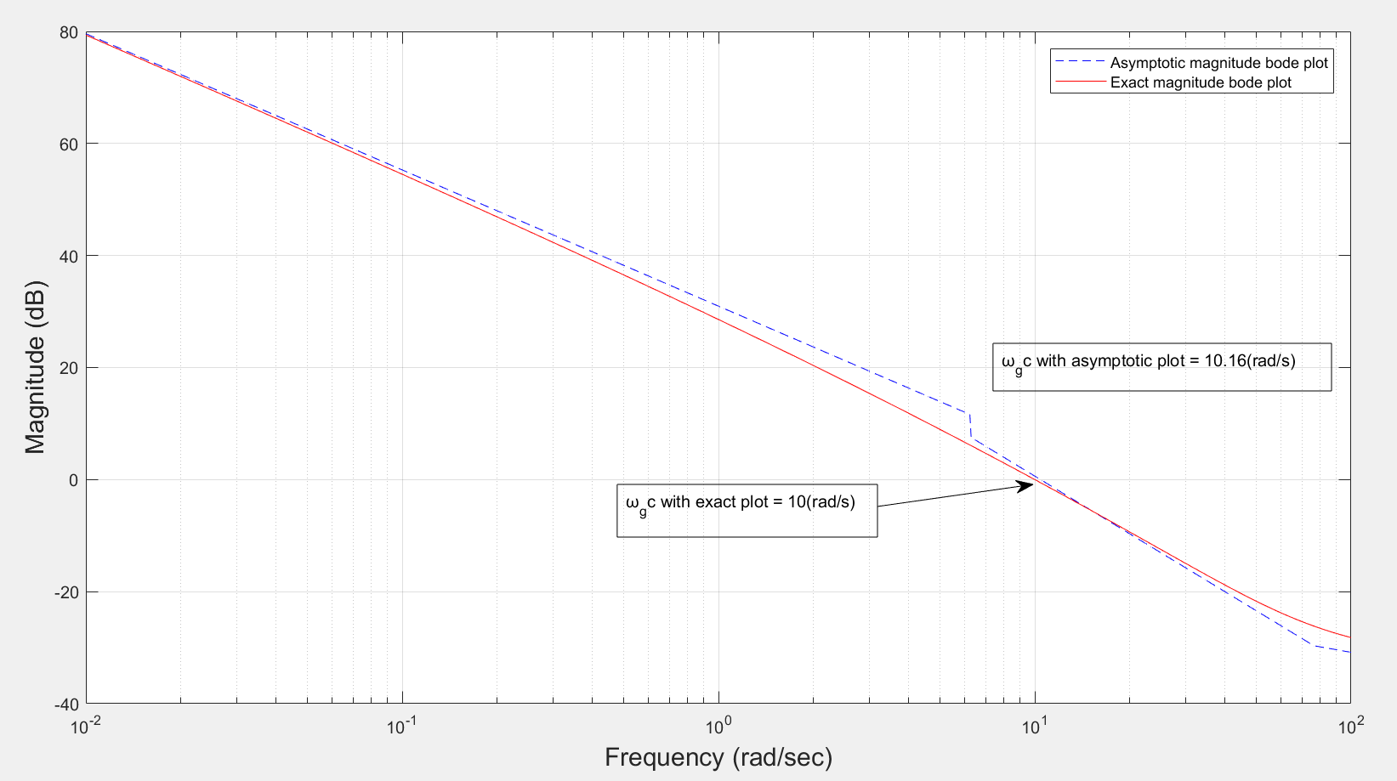

Fig 7: Real and asymptotic magnitude bode plot for L(s)

From fig 7, $ω_{gc}$ is obtained as:

1. $ω_{gc}$ for asymptotic = 10.16(rad/sec)
2. $ω_{gc}$ for exact plot = 10 (rad/sec)

**Matlab**

clc;

clf;

clear all;

close all;

Kp = 0.1817;

Ki = 194.4;

beta = 1.216;

alpha = 0.5;

Wcr = (abs(Ki))^(1/beta);

Wcr1 = (abs(1/0.4))^(1/alpha);

w = logspace(-2 , 2, 1000);

mask = w < Wcr;

mask1 = w < Wcr1;

mag1 = 20*log10(Kp)*ones(size(w));

mag2 = mask.*(20*log10(Ki)) + (~mask).*(20*beta*log10(w));

mag3 = -20*beta*log10(w);

mag4= (mask1).*(-20*log10(1)) + (~mask1).*(-20*alpha*log10(0.4*w));

combined = mag1 + mag2 + mag3 + mag4;

figure(1);

plot(1,1);

semilogx(w, mag1)

xlabel('Frequency(rad/sec)','FontSize', 15);

ylabel('Magnitude dB','FontSize', 15);

grid on;

figure(2);

plot(1,2);

semilogx(w, mag2)

xlabel('Frequency(rad/sec)','FontSize', 15);

ylabel('Magnitude dB','FontSize', 15);

grid on;

figure(3);

plot(1,3);

semilogx(w, mag3)

xlabel('Frequency(rad/sec)','FontSize', 15);

ylabel('Magnitude dB','FontSize', 15);

grid on;

figure (4);

plot(1,4);

semilogx(w, mag4)

xlabel('Frequency(rad/sec)','FontSize', 15);

ylabel('Magnitude dB','FontSize', 15);

grid on;

figure(5);

plot(1,5);

semilogx(w, combined,'Color','blue','LineStyle','--')

xlabel('Frequency(rad/sec)','FontSize', 15);

ylabel('Magnitude dB','FontSize', 15);

grid on;

legend('Asymptotic magnitude bode plot','Location','NorthEast');

plot(1,1);

semilogx(w, combined,'Color','blue','LineStyle','--')

xlabel('Frequency(rad/sec)','FontSize', 15);

ylabel('Magnitude dB','FontSize', 15);

grid on;

hold on;

clc;

clear

beta = 1.216;

alpha = 0.5;

K=1;

T=0.4;

Kp=0.1817;

Ki=194.4;

w=logspace(-2,2,1000);

Mag=@(w) 20*log10(abs(sqrt(K).^2)) + 20*log10(abs(sqrt(Kp).^2)) + 20*log10(abs(sqrt((1i.*w).^beta +Ki).^2)) - 20*log10(abs(sqrt(T*(1i.*w).^alpha + 1).^2)) - 20*log10(abs(sqrt((1i.*w).^beta).^2));

semilogx(w,Mag(w),'Color','red');

hold on;

grid on;

xlabel('Frequency (rad/sec)','FontSize', 15);

ylabel('Magnitude (dB)','FontSize', 15);

legend('Asymptotic magnitude bode plot','Exact magnitude bode plot','Location','NorthEast')